RoamReady — UX Mockups
Visual reference for the Navigation Restructure hand-off
Prepared by Cindy (UX) · May 20, 2026

These are the locked design targets that accompany the written hand-off doc (RoamReady_HandOff_Navigation_Restructure.docx). Mockups show layout, hierarchy, and the locked status-pill colors — not final copy or live data. Pair each image with its matching section in the hand-off for implementation notes.

1 · New Home — AI canvas as the landing page
The conversational planner becomes the front door. The “Continue planning” strip sits below the watermark, visually separated from the canvas, with a “View all in Dashboard” link. Maps to hand-off Section 1.
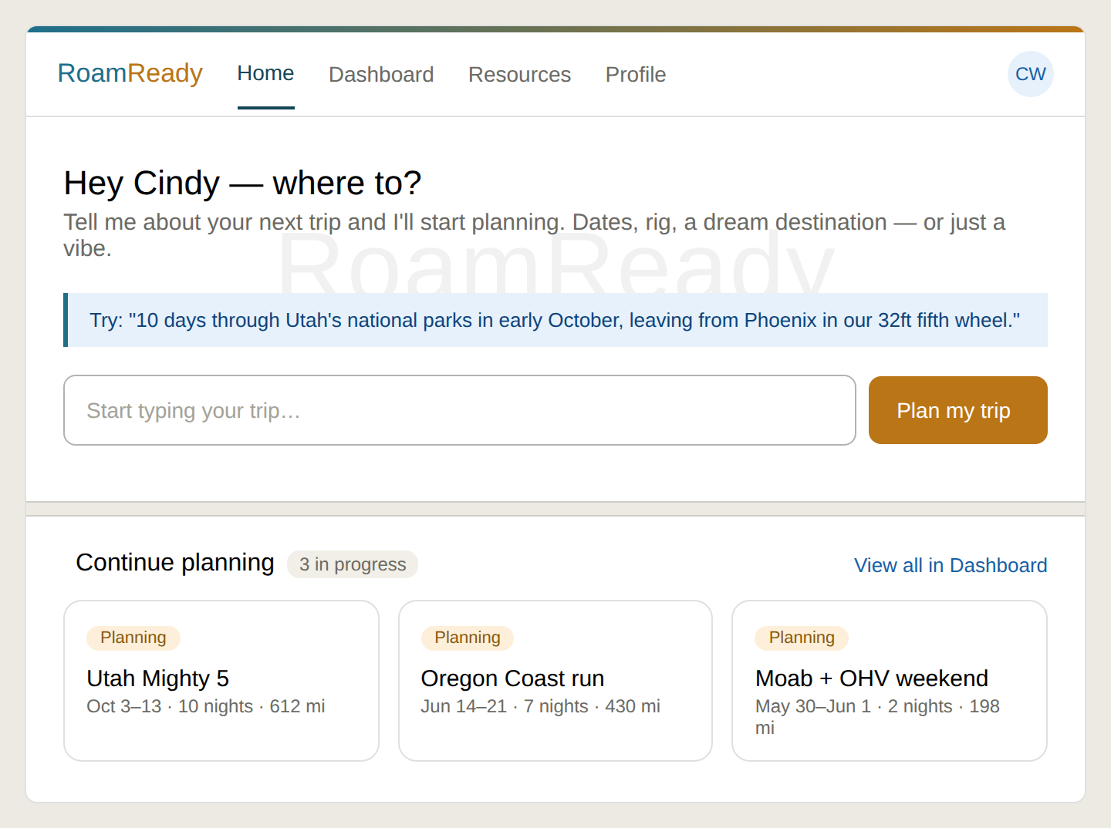

2 · Merged Dashboard — Trips view (default)
Old Dashboard + Trips combined into one page. Trial banner on top, gold “Plan a new trip” CTA (routes to Home), and status filter tabs (Active default). The Reservations tab sits after a divider as a different lens. Maps to hand-off Sections 2 & 4.
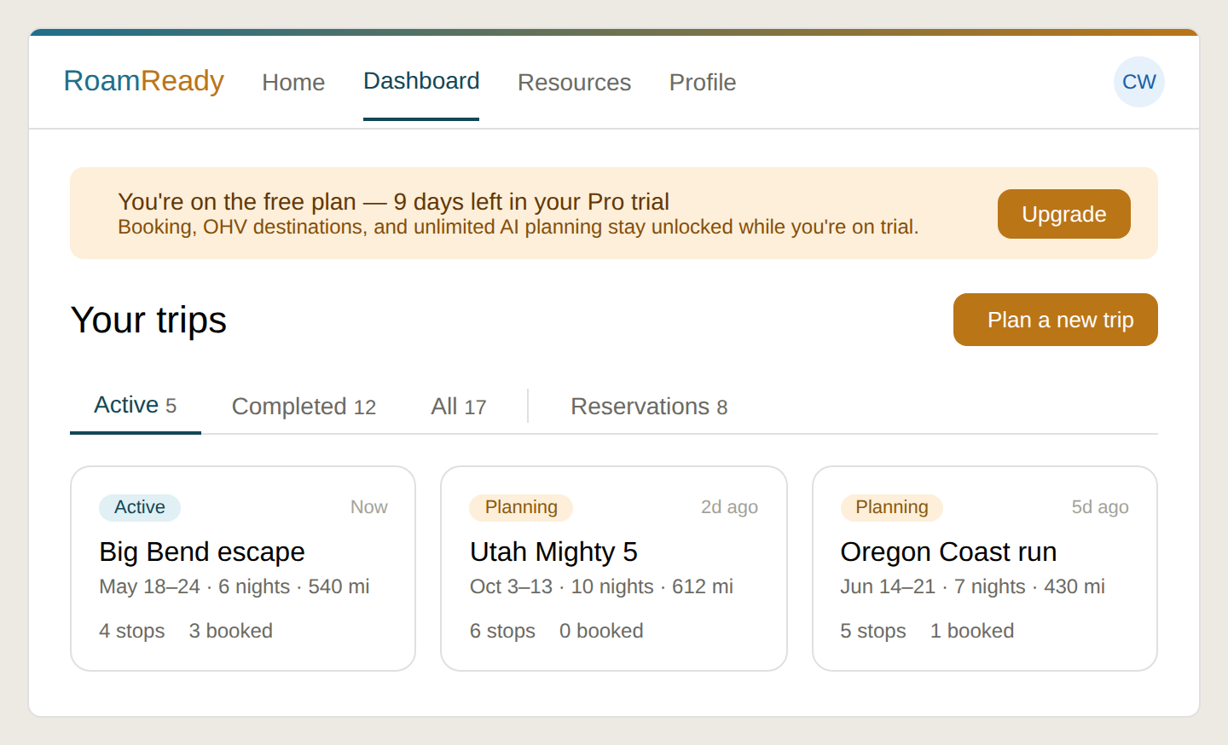

3 · Dashboard — Reservations tab active
Same page, content swapped to a cross-trip booking roll-up grouped Upcoming/Past by date. Each row is tagged with its trip and carries a status pill. Tapping a row drills into that trip’s booking page. Maps to hand-off Section 4.
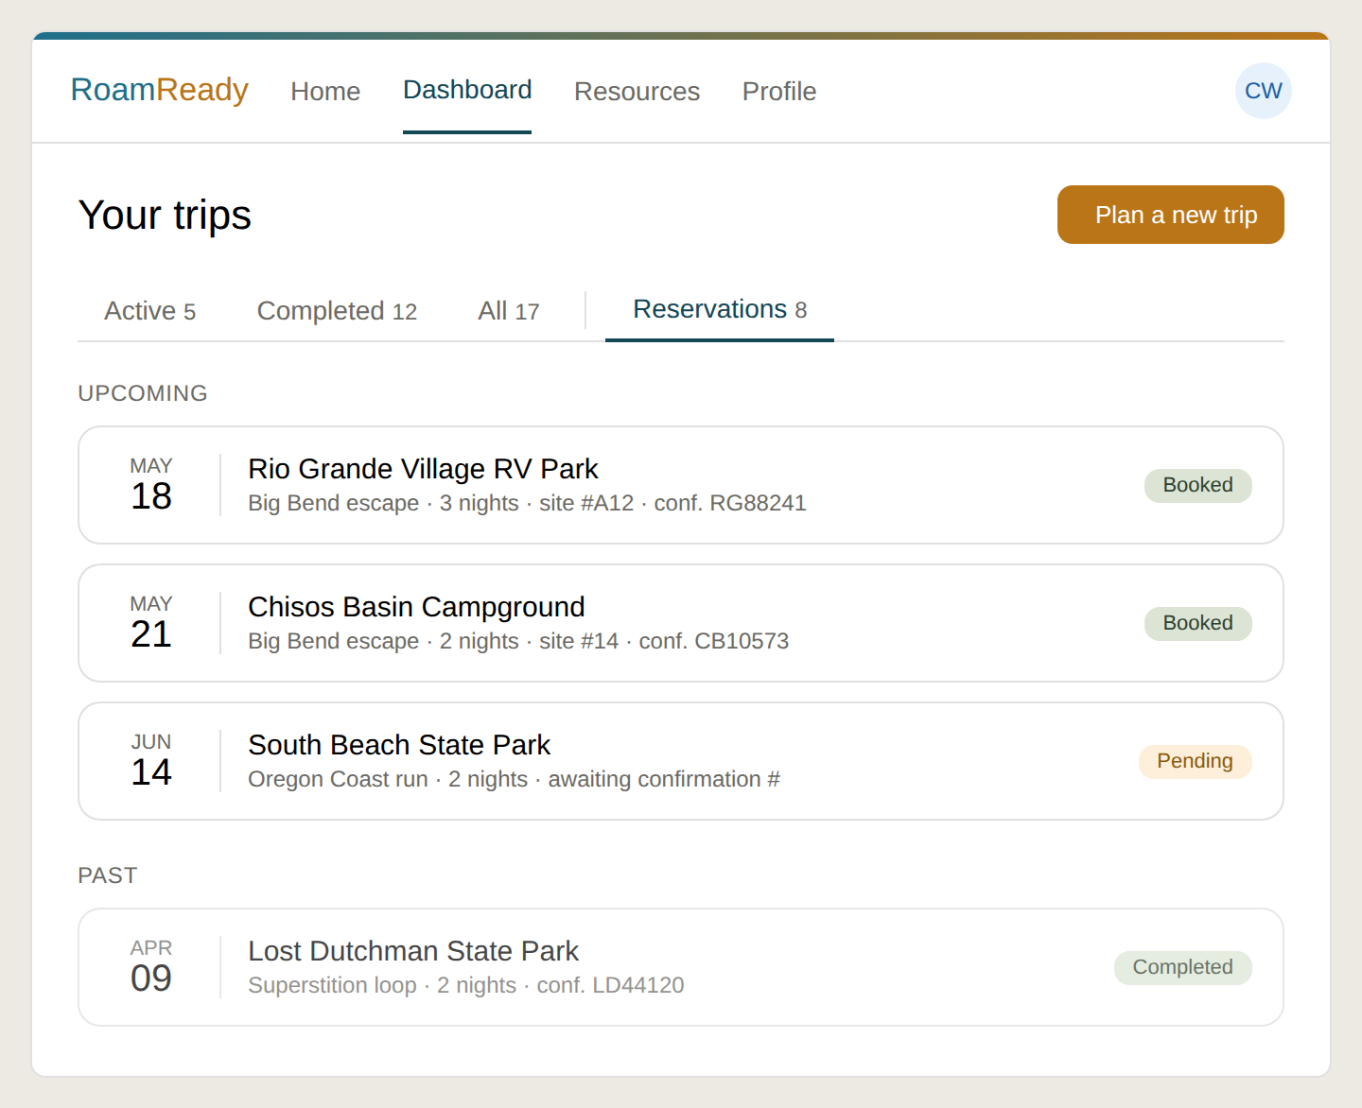
Martini AI Media LLC | DBA Roamready.ai | Arizona | May 20, 2026

